 East West University

**Department of CSE**

**LAB REPORT**

|  |  |
| --- | --- |
| **Course Code and Name:** CSE-209 Electrical Circuits | |
| **Experiment no:** 02  **Group**-07 | |
| **Experiment name:** Series-Parallel DC Circuit and Verification of Kirchhoff’s Laws | |
| **Name of Students**  Shaff Zaman Khan **ID**: 2023-3-60-**338**  Sumya Kawsar **ID**:2023-3-60-**168**  Md. Hasib Ali **ID**:2023-3-60-**186** | **Course Instructor information:**  M. Saddam Hossain Khan  Senior Lecturer  Department of Computer Science and  Engineering |
| Date of Submission: 18th March, 2025 | **Pre-lab marks:** |
| **Post-lab marks:** |
| **Total marks:** |

**Experiment Name: Series-Parallel DC Circuit and Verification of Kirchhoff’s Laws**

**Abstract:**

This experiment analyzes series-parallel DC circuits and verifies Kirchhoff’s Voltage Law (KVL) and Kirchhoff’s Current Law (KCL). KVL states that the sum of all voltage rises in a closed loop equals the sum of all voltage drops, while KCL states that the sum of currents entering a node is equal to the sum of currents leaving it. A circuit was constructed with both series and parallel resistor combinations, and voltage and current values were measured to validate these laws. The results were analyzed to compare theoretical and experimental values.

**Objectives:**

* To analyze series-parallel DC circuits.
* To verify Kirchhoff’s Voltage Law (KVL).
* To verify Kirchhoff’s Current Law (KCL).
* To measure voltage and current in different circuit configurations.
* To develop practical circuit analysis skills.

**Theory:**

In an electrical circuit, components are connected in different configurations, such as series, parallel, or a combination of both. This experiment focuses on analyzing series-parallel DC circuits and verifying Kirchhoff’s Voltage Law (KVL) and Kirchhoff’s Current Law (KCL).

Kirchhoff’s Voltage Law (KVL) states that the sum of all voltage rises in a closed loop is equal to the sum of all voltage drops. Mathematically, it is expressed as:

This law is useful in analyzing circuits where multiple voltage sources and resistors are present. In a simple series circuit, voltage sources (E1 and E2) and resistors (R1 and R2) contribute to the total voltage drop across the components, as given by the equation:

where V1 and V2 are the voltage drops across resistors R1 and R2, respectively.

Kirchhoff’s Current Law (KCL) states that the sum of all currents entering a node in a circuit must equal the sum of all currents leaving the node. Mathematically, it is expressed as:

For example, in a simple parallel circuit with a voltage source E and two resistors R1 and R2, the source current Is is divided into I1 and I2, where:

A series-parallel circuit consists of both series and parallel resistor combinations. The parallel and series resistances must be determined separately to analyze such a circuit. For example, in a circuit where resistors R2 and R3 are in parallel and their combination is in series with R1, the equivalent resistance Req is given by:

Using Ohm’s Law (V = IR), the voltage drops and currents can be determined for each component, and the laws of KVL and KCL can be verified through experimental measurements.

**Experimental Method:**

* Measure the resistance values of the supplied resistors using a multimeter.
* Construct the circuit according to the given diagram.
* Set the voltage source to a specified value (e.g., 3V).
* Measure the voltage drops across each resistor and record the values.
* Measure the currents flowing through different branches of the circuit.
* Verify KVL by summing the voltage drops and comparing them with the total supplied voltage.
* Verify KCL by checking that the sum of entering currents equals the sum of leaving currents at a node.
* Compare the theoretical and experimental results.

**Circuit Diagram:**

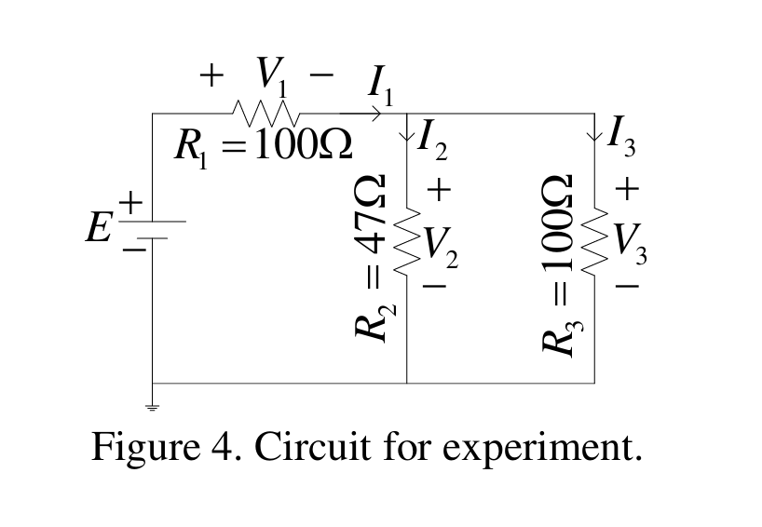

**Experimental Data:**

|  |  |  |  |  |  |  |  |
| --- | --- | --- | --- | --- | --- | --- | --- |
| **Measured Value of E(V)** | **Measured Value of V1 (V)** | **Measured Value of V2 (V)** | **Measured Value of V3 (V)** | **Measured Value of I1 (mA)** | **Measured Value of I2 (mA)** | **Measured Value of I3 (mA)** | **Measured Value of Resistance ()** |
| **2.75** | **2.15** | **0.712** | **0.725** | **21.9** | **15.0** | **6.4** | **R1= 97.3 R2= 46.4 R3= 99.7** |

**Post Lab Questions**

**1. Calculate the values of V1, V2, V3, I1, I2, and I3 of the circuit of Figure 4 using measured values of E, R1, R2, and R3. Compare the calculated values with the measured values and give reason if any discrepancy is found.**

**Solution:**

From the circuit, Since R2 and R3 are in parallel:  
calculate the equivalent resistance:

Resistance,

We know,

In parallel circuit, voltages are equal, so

Now,

**2. From the calculated values, show that (i) , (ii) KVL holds, that is, , and (iii) KCL holds, that is, .**

**Solution:**

From the calculated values we get,

1. From the calculated values we get, V

Applying Kirchhoff’s Voltage Law (KVL):

This confirms that KVL holds in the circuit.

1. Applying Kirchhoff’s Current Law (KCL):

Therefore,

Hence, it is confirmed that KCL holds in the circuit.

From the calculated and measured values, we can observe that there are some little differences between these values. This is due to discrepancies in the resistors that were provided for the lab and these happened mainly because of mechanical and human error

**Results and Discussion:**

The measured voltage of the power source was 2.75V, with voltage drops across resistors R1, R2, R3, and recorded as 2.15V, 0.712V, and 0.725V, respectively. The sum of these voltage drops closely matches the supplied voltage, confirming Kirchhoff’s Voltage Law (KVL).

The measured currents through different branches were 21.9mA for I1, 15.0mA for I2, and 6.4mA for I3. The sum of I2 and I3 (15.0mA + 6.4mA = 21.4mA) is very close to I1, validating Kirchhoff’s Current Law (KCL) with minor discrepancies attributed to measurement errors.

The experimental resistance values were R1 = 97.3, R2 = 46.4, and R3 = 99.7. The results align well with theoretical predictions, confirming the validity of the laws.

**Conclusion:**

This experiment provided a hands-on approach to understanding Kirchhoff’s laws in series-parallel DC circuits. By measuring voltages and currents and comparing them with theoretical values, the validity of KVL and KCL was confirmed. The small deviations observed highlight the importance of precision in measurements and circuit connections. Overall, the experiment reinforced fundamental circuit analysis concepts and demonstrated their practical applications.

**Pre-Lab of Group members:**

**